Software Requirements Specification
  - WealthFlow - Personal Finance & Investment Platform

Version | Description of Change | Author | Date
1.0.0 | First draft including core functional requirements and system architecture. | Muzaffer Demirhan | 29.06.2026
1.1.0 | Reformatted document structure for improved readability. Added System Architecture and ER Diagram. | Muzaffer Demirhan | 30.06.2026

Date: 2026-06-29
Status: Working in Progress (WIP) Draft

Table of Contents
1. Introduction 2
1.1 Purpose 2
1.2 Scope 2
1.3 Target Audience 3
1.4 Definitions 3
2. Overall Description 3
2.1 Product Perspective 3
2.2 User Classes 3
2.3 Operating Environment 4
3. Functional Requirements 4
3.1 Authentication & Authorization 4
3.2 Bank Account Integration 4
3.3 Transaction Management 4
3.4 Dashboard & Analytics 5
3.5 Budget Management 5
3.6 Investment Portfolio 5
3.7 AI Financial Advisor 5
3.8 Reports & Export 6
4. Non-Functional Requirements 6
5. System Architecture 7
6. Database Schema 8
6.1 Entity Relationship Diagram 8
6.2 Core Tables 8
User 9
Category 9
Bank Account 9
Transaction 9
Budget 10
Portfolio Holding 10
7. API Specification 10
8. Tech Stack 12
9. Scrum Plan 12
10. Risks & Mitigations 14

1. Introduction

1.1 Purpose
This document defines the software requirements for WealthFlow, a full-stack personal finance and investment tracking platform. It serves as the single source of truth for all development decisions and is updated iteratively as the project evolves.

1.2 Scope
WealthFlow allows users to:
- Connect bank accounts via Open Banking APIs (Plaid/Nordigen)
- Automatically categorize transactions using a machine learning classifier
- Track investment portfolios (stocks, crypto, funds)
- Set budgets and receive real-time alerts
- Get AI-powered financial advice via a chatbot
- Export reports as PDF or CSV

1.3 Target Audience
- Primary users: Professionals aged 25 - 40 managing multiple income streams and investments
- Market: EU/Poland (PSD2-compliant Open Banking)

1.4 Definitions
Term | Definition
Open Banking | Standart allowing third-party access to bank data via APIs under PSD2.
PSD2 | EU Payment Services Directive 2 - mandates Open Banking.
JWT | JSON Web Token - stateless authentication mechanism.
ML | Machine Learning model for transaction classification.

2. Overall Description

2.1 Product Perspective
WealthFlow is a standalone web application with a REST API backend. It integrates with:
- Plaid / Nordigen for bank account data.
- Alpha Vantage / Yahoo Finance for market data.
- Anthropic Claude API for the AI financial advisor chatbot.

2.2 User Classes
User Class | Description
Authenticated User | Full access to all features.
Guest | Landing page only, no data access.
Admin | User management, system monitoring.

2.3 Operating Environment
- Frontend: Modern browsers (Chrome 120+, Firefox 120+, Safari 17+)
- Backend: Linux (Ubuntu 22.04 LTS) via Docker
- Database: MS SQL Server 2022
- Deployment: Railway (MVP), scalable to AWS/GCP

3. Functional Requirements

3.1 Authentication & Authorization
ID | Requirement | Priority
FR-01 | User registration with email + password | High
FR-01 | Login with JWT access + refresh tokens | High
FR-03 | Oauth2 social login (Google) | Medium
FR-04 | Password reset via email | Medium
FR-05 | Role-based access control (user/admin) | High

3.2 Bank Account Integration
ID | Requirement | Priority
FR-06 | Connect bank accounts via Plaid Link / Nordigen | High
FR-07 | Fetch and store transaction history (90 days) | High
FR-08 | Real-time balance updates via webhooks | Medium
FR-09 | Support multiple accounts per user | High
FR-10 | Disconnect account and delete associated data | High

3.3 Transaction Management
ID | Requirement | Priority
FR-11 | Auto-categorize transactions using ML model | High
FR-12 | Manual category override by user | High
FR-13 | Search and filter transactions | Medium
FR-14 | Add manual transactions (cash) | Low
FR-15 | Recurring transaction detection | Medium

3.4 Dashboard & Analytics
ID | Requirement | Priority
FR-16 | Monthly income vs expense chart | High
FR-17 | Spending breakdown by category (pie/donut chart) | High
FR-18 | Net worth over time (line chart) | High
FR-19 | Cash flow heatmap (daily spending) | Medium
FR-20 | Saving rate calculation | Medium

3.5 Budget Management
ID | Requirement | Priority
FR-21 | Create monthly budgets per category | High
FR-22 | Progress bar tracking against budget | High
FR-23 | Push notification when 80% of budget used | Medium
FR-24 | Budget history and comparison | Low

3.6 Investment Portfolio
ID | Requirement | Priority
FR-25 | Add holdings (ticker, shares, purchase price) | High
FR-26 | Real-time price fetch from market API | High
FR-27 | Portfolio performance (P&L, %) | High
FR-28 | Asset allocation pie chart | Medium
FR-29 | Historical portfolio value chart | Medium

3.7 AI Financial Advisor
ID | Requirement | Priority
FR-30 | Chatbot powered by Claude API | Medium
FR-31 | Context-aware (knows user’s transactions/budgets) | Medium
FR-32 | Suggest savings opportunities | Low
FR-33 | Persistent chat history | Low

3.8 Reports & Export
ID | Requirement | Priority
FR-34 | Monthly PDF report generation | Medium
FR-35 | CSV export of transactions | Medium
FR-36 | Email delivery of reports | Low

4. Non-Functional Requirements

ID | Requirement | Target
NFR-01 | API respons time (p95) | < 200ms
NFR-02 | Uptime SLA | 99.9%
NFR-03 | Data encryption at rest | AES-256
NFR-04 | Data encryption in transit | TLS 1.3
NFR-05 | GDPR compliance | Full deletion & export
NFR-06 | OWASP Top 10 | All mitigated
NFR-07 | Lighthouse performance score | > 90
NFR-08 | Mobile responsive | All breakpoints
NFR-09 | Test coverage | > 80% (unit + integration)
NFR-10 | API rate limiting | 100 req/min per user

5. System Architecture

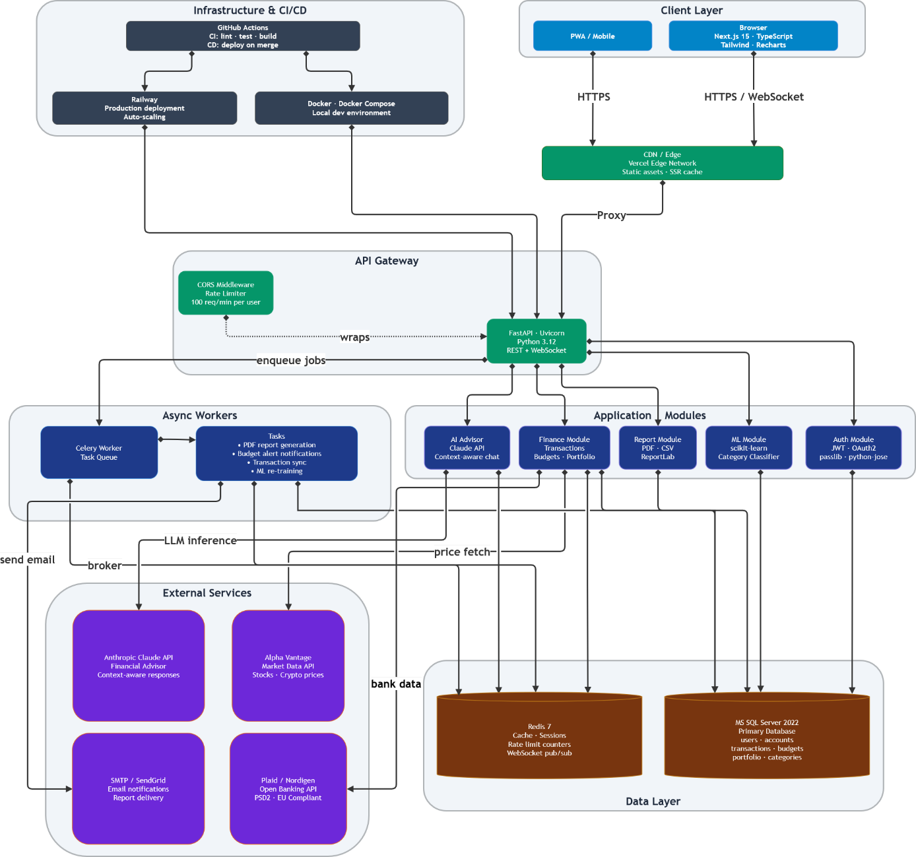

6. Database Schema

6.1 Entity Relationship Diagram

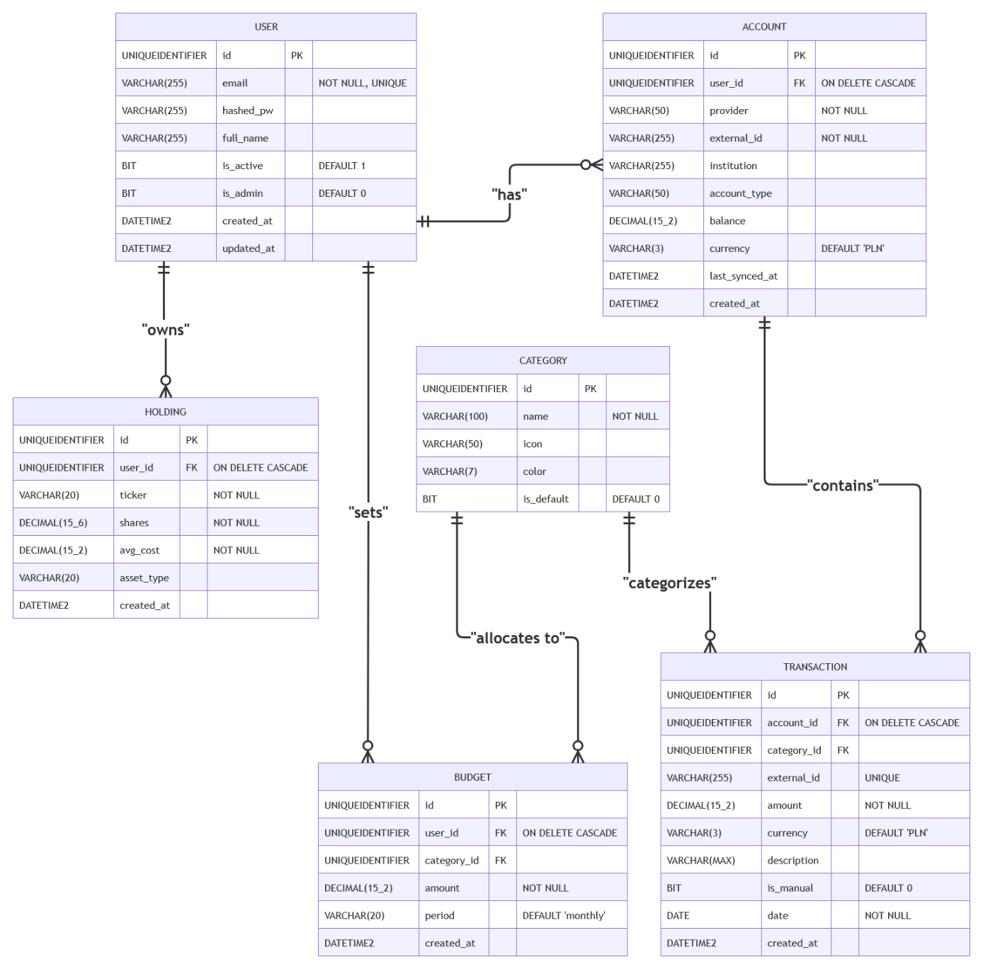

6.2 Core Tables
These are SQL codes that has been created within MS SQL Server 2022.

User
CREATE TABLE user (
id UNIQUEIDENTIFIER PRIMARY KEY DEFAULT NEWID(),
email VARCHAR(255) UNIQUE NOT NULL,
hashed_pw VARCHAR(255),
full_name VARCHAR(255),
is_active BIT DEFAULT 1,
is_admin BIT DEFAULT 0,
created_at DATETIME2 DEFAULT GETUTCDATE(),
updated_at DATETIME2 DEFAULT GETUTCDATE()
);

Category
CREATE TABLE category (
id UNIQUEIDENTIFIER PRIMARY KEY DEFAULT NEWID(),
name VARCHAR(100) NOT NULL,
icon VARCHAR(50),
color VARCHAR(7),
is_default BIT DEFAULT 0
);

Bank Account
CREATE TABLE account (
id UNIQUEIDENTIFIER PRIMARY KEY DEFAULT NEWID(),
user_id UNIQUEIDENTIFIER REFERENCES users(id) ON DELETE CASCADE,
provider VARCHAR(50) NOT NULL, -- 'plaid' | 'nordigen'
external_id VARCHAR(255) NOT NULL,
institution VARCHAR(255),
account_type VARCHAR(50), -- checking | savings | credit
balance DECIMAL(15,2),
currency VARCHAR(3) DEFAULT 'PLN',
last_synced_at DATETIME2,
created_at DATETIME2 DEFAULT GETUTCDATE()
);

Transaction
CREATE TABLE transaction (
id UNIQUEIDENTIFIER PRIMARY KEY DEFAULT NEWID(),
account_id UNIQUEIDENTIFIER REFERENCES accounts(id) ON DELETE CASCADE,
external_id VARCHAR(255) UNIQUE,
amount DECIMAL(15,2) NOT NULL,
currency VARCHAR(3) DEFAULT 'PLN',
description VARCHAR(MAX),
category_id UNIQUEIDENTIFIER REFERENCES categories(id),
is_manual BIT DEFAULT 0,
date DATE NOT NULL,
created_at DATETIME2 DEFAULT GETUTCDATE()
);

Budget
CREATE TABLE budget (
id UNIQUEIDENTIFIER PRIMARY KEY DEFAULT NEWID(),
user_id UNIQUEIDENTIFIER REFERENCES users(id) ON DELETE CASCADE,
category_id UNIQUEIDENTIFIER REFERENCES categories(id),
amount DECIMAL(15,2) NOT NULL,
period VARCHAR(20) DEFAULT 'monthly',
created_at DATETIME2 DEFAULT GETUTCDATE()
);

Portfolio Holding
CREATE TABLE holding (
id UNIQUEIDENTIFIER PRIMARY KEY DEFAULT NEWID(),
user_id UNIQUEIDENTIFIER REFERENCES users(id) ON DELETE CASCADE,
ticker VARCHAR(20) NOT NULL,
shares DECIMAL(15,6) NOT NULL,
avg_cost DECIMAL(15,2) NOT NULL,
asset_type VARCHAR(20), -- stock | crypto | etf | fund
created_at DATETIME2 DEFAULT GETUTCDATE()
);

7. API Specification

Base URL: `/api/v1`

Authentication
```
POST /auth/register Register new user
POST /auth/login Login, returns JWT pair
POST /auth/refresh Refresh access token
POST /auth/logout Invalidate refresh token
POST /auth/password-reset Send reset email
```

Account
```
GET /account List user's connected accounts
POST /account/connect Initiate Open Banking connection
DELETE /account/{id} Disconnect account
GET /account/{id}/sync Force sync transactions
```

Transaction
```
GET /transaction List (filter: date, category, account)
GET /transaction/{id} Get single transaction
PATCH /transaction/{id} Update category
POST /transaction Create manual transaction
```

Budget
```
GET /budget List budgets with progress
POST /budget Create budget
PUT /budget/{id} Update budget
DELETE /budget/{id} Delete budget
```

Portfolio
```
GET /portfolio Holdings with current prices + P&L
POST /portfolio/holding Add holding
DELETE /portfolio/holding/{id} Remove holding
```

Report
```
GET /report/monthly Monthly summary (JSON)
GET /report/pdf Download PDF report
GET /report/csv Download transactions CSV
```

8. Tech Stack
Layer | Technology | Rationale
Frontend | Next.js 15 + TypeScript | SSR, type safety, strong EU job market demand
Styling | Tailwind CSS | Rapid UI development
Charts | Recharts | React-native charting
Backend | FastAPI (Python 3.12) | Async, auto-docs, ML-friendly
ORM | SQLAlchemy 2.0 + Alembic | Type-safe queries, migrations
Database | MS SQL Server 2022 | ACID, JSON support, mature
Cache | Redis 7 | Session store, rate limiting
Task Queue | Celery + Redis broker | Async jobs (reports, notifications)
ML | scikit-learn | Transaction classifier
Auth | JWT + python-jose | Stateless, scalable
Containerization | Docker + Docker Compose | Reproducible environments
CI/CD | Github Actions | Automated test + deploy
Deployment | Railway | Simple PaaS, free tier
Testing | pytest + React Testing Library | >80% coverage target

9. Scrum Plan

Sprint 0 - Foundation (Week 1)
- [x] SRS document
- [x] System architecture diagram
- [x] Database ERD
- [x] Project scaffolding (repo structure, Docker Compose)

Sprint 1 - Backend Core (Weeks 2–3)
- [ ] FastAPI project setup with folder structure
- [ ] MS SQL Server 2022+ Alembic migrations
- [ ] User model + JWT auth endpoints
- [ ] Docker Compose (FastAPI + MS SQL Server 2022 + Redis)
- [ ] GitHub Actions CI (lint + test)

Sprint 2 - Data Layer (Weeks 4–5)
- [ ] Plaid/Nordigen integration (sandbox)
- [ ] Transaction ingestion pipeline
- [ ] ML classifier for categories (scikit-learn)
- [ ] Celery worker setup
- [ ] REST endpoints: accounts, transactions, budgets

Sprint 3 - Frontend (Weeks 6–7)
- [ ] Next.js project setup + Tailwind
- [ ] Auth pages (login, register)
- [ ] Dashboard with Recharts
- [ ] Transactions list + filter
- [ ] Portfolio view

Sprint 4 - AI & Polish (Week 8)
- [ ] Claude API chatbot integration
- [ ] WebSocket notifications
- [ ] PDF report generation (ReportLab)
- [ ] Railway deployment
- [ ] End-to-end tests

Launch (Week 9)
- [ ] English README with screenshots
- [ ] Demo GIF
- [ ] GitHub profile pinning
- [ ] LinkedIn post

10. Risks & Mitigations

Risk | Likelihood | Impact | Mitigation
Open Banking API rate limits | Medium | High | Cache responses in Redis, use webhooks
ML classifier low accuracy | Medium | Medium | Start with rule-based fallback
GDPR non-compliance | Low | High | Encrypt PII, implement data deletion
Railway downtime | Low | Medium | Health checks, auto-restart
Scope creep | High | Medium | Strict sprint backlog, MoSCoW prioritization

